**Project 1**

**LED BLINKING**

It is a classic project to understand the basic input/output operations and delay functions.

Blinking an LED is an introductory Arduino project in which we control an LED using Arduino. LED blinking refers to the process of continuously turning an LED (Light Emitting Diode) and off in a repetitive pattern. It is a simple and common demonstration in electronics and microcontroller-based projects.

**Working Procedure:**

setup() and loop() are two fundamental Arduino functions for controlling the behavior of your board. The Arduino framework automatically calls these functions, which form the foundation of any Arduino program.

**The setup() function** is only called once when the Arduino board boots up or is reset. Its goal is to set pin modes, initialize variables, and execute any other necessary setup tasks before the main loop begins. This function can be used to configure settings that should only be changed once over the board’s lifespan.

**The loop() function**is the heart of an Arduino program. After the setup() function is executed, the loop() function starts running repeatedly until the Arduino is powered off or reset. It contains the main code that performs the desired tasks, controls the board, user input. Whatever is included in the loop() function will be executed in a continuous loop, allowing the Arduino to perform its intended functions continuously.

**Components Required:**

1. 1 X LED
2. 1 X Resistor, 220 Ohm
3. Breadboard
4. Arduino UNO R4 or earlier versions.
5. Jumper wires

**Circuit Diagram:**

In the circuit diagram, we used one 220-ohm resistor in series with the [LED.](https://www.geeksforgeeks.org/introduction-of-led/) This resistor is also called a current-limitingresistor. The Anode of the LED (the longer pin) is connected to one end of the resistor, and the cathode (the shorter pin) is connected to the ground. The other end of the resistor is connected to the Arduino pin. A step-by-step explanation is as follows:

1. **LED Connections:**Connect the LED to the breadboard. The LED has two legs, the longer of which is the anode (positive) and the shorter of which is the cathode (negative).
2. **Resistor Connection:**Insert one end of the resistor into the same row of the breadboard as the LED’s Anode. The resistor’s other end should be connected to the Arduino’s digital output pin.
3. **Ground (GND) Connection:** Connect a jumper wire from the same row as the LED’s cathode to any Arduino board GND (Ground) pin. This connects the circuit to the ground of the Arduino.

The circuit is now complete:

When you upload a simple Arduino program that controls the LED, the microcontroller on the Arduino board executes the program, and the LED will blink according to the code you wrote.

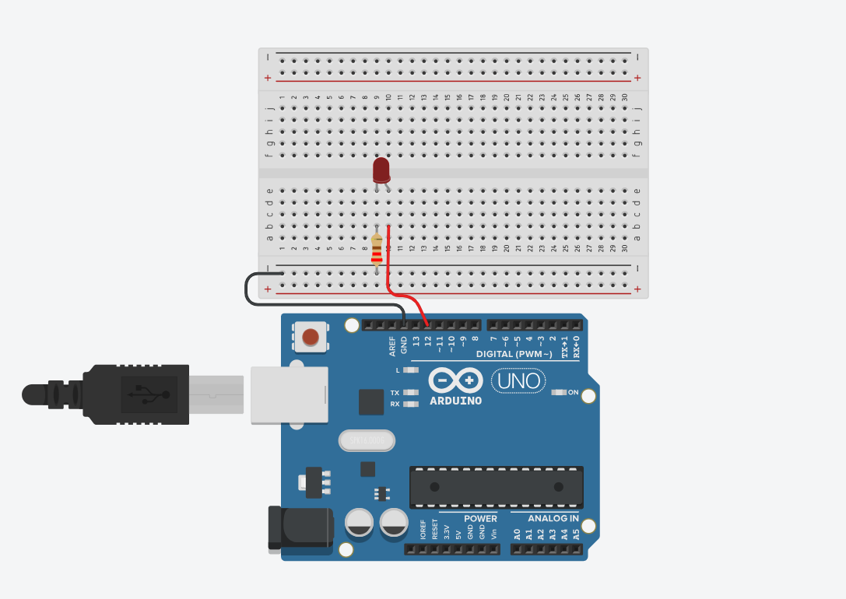

**CODE:**

int led=12;

void setup()

{

pinMode(led, OUTPUT);

}

void loop()

{

digitalWrite(led, HIGH);

delay(1000); // Wait for 1000 millisecond(s)

digitalWrite(led, LOW);

delay(1000); // Wait for 1000 millisecond(s)

}

**OUTPUT:**

The LED blinks every second.

